Lab 0 - SETUP LAB ENVIRONMENT

Table of Contents
0.1. INSTALL ZEND STUDIO 2
0.1.1. Download Zend Studio 2
0.1.2. Install Zend Studio 2
0.2. INSTALL ZEND SERVER COMMUNITY 6
0.2.1. Download Zend Server Community Edition 6
0.2.2. Install Zend Server Community Edition 6
0.3. INTEGRATED ADMINISTRATION CONSOLE 13
0.3.1. Monitor 13
0.3.2. Server setup 14
0.3.3. Administration: 17
0.4. HELLO WORLD 17
0.5. EXAMPLE PROJECT 18
0.5.1. Creating the Zend Framework Example Project 18
0.5.2. Apache configuration 18
0.5.3. Run ExampleProject 19
REFERENCES 20

0.1. INSTALL ZEND STUDIO

0.1.1. Download Zend Studio
1. Go to http://www.zend.com/en/products/studio/downloads and choose to download ZendStudio-7.0.0.exe.

0.1.2. Install Zend Studio
2. Run the Zend Studio 7.0 installation file:
ZendStudio-7.0.0.exe
3. The installer will launch.
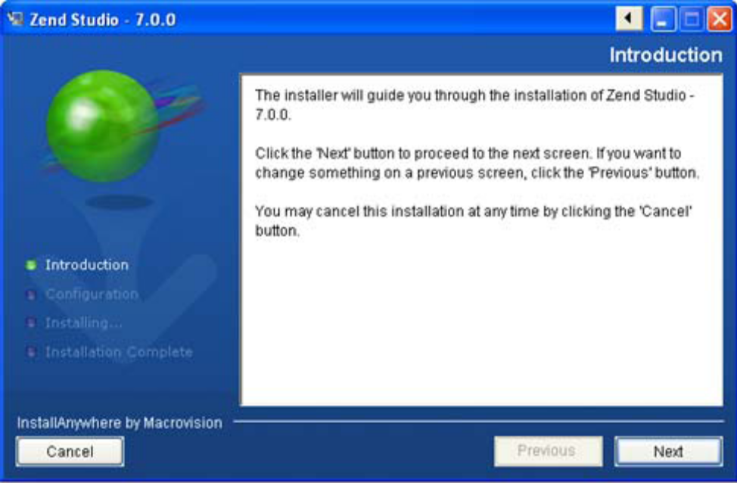
4. Click Next. The License Agreement screen is displayed.
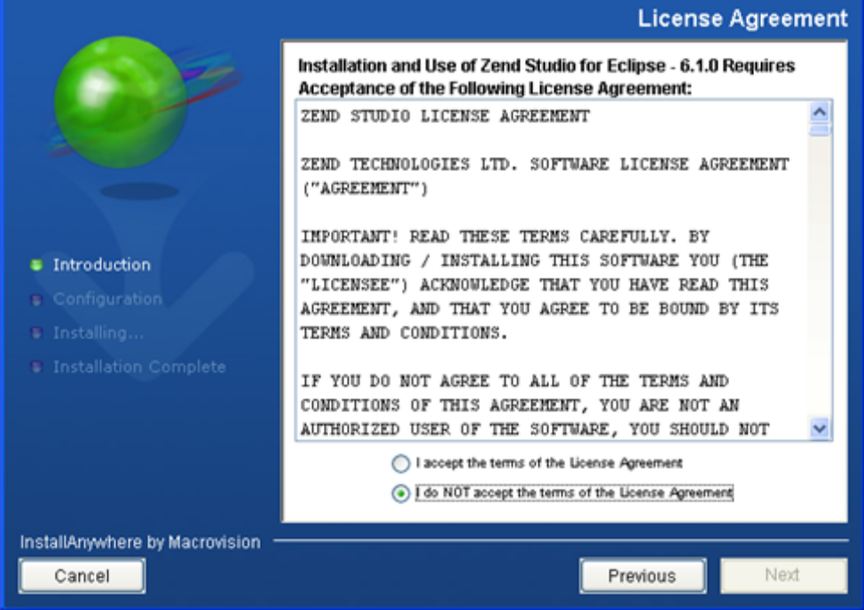
5. Select the ‘I accept the terms of the License Agreement’ radio button and click Next to continue with the installation. If you do not accept the terms, click Cancel. The installation process will be aborted. If you accepted the license agreement, the Choose Install Set screen is displayed.
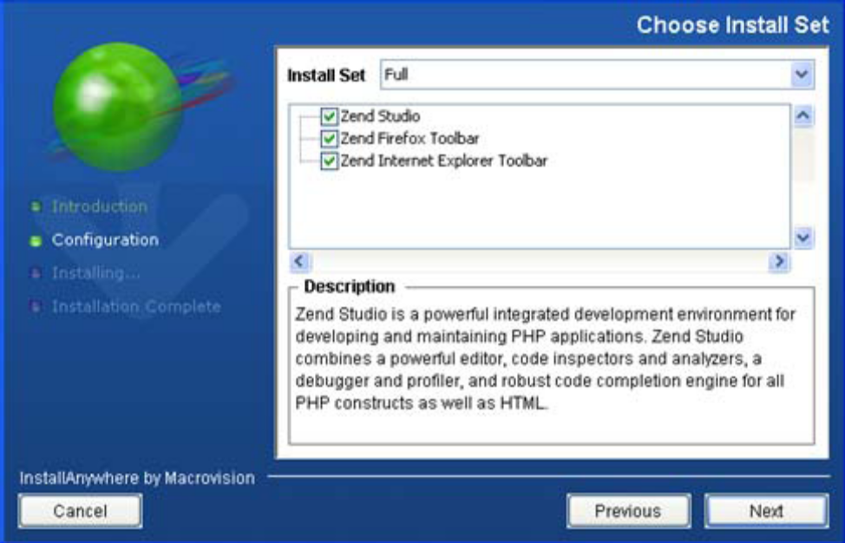
6. Mark the checkboxes of the components which you would like to install:
▪ Zend Studio – The Zend Studio 7.x IDE.
▪ Zend Firefox Toolbar / Zend Internet Explorer Toolbar - Allow you to debug pages and applications directly from your Internet Explorer or Firefox browsers (Zend Studio must be installed). See the Zend Browser Toolbar topic in the Zend Studio Online Documentation Center for more information.
7. Click Next. The Choose Install Folder and Shortcuts screen is displayed.
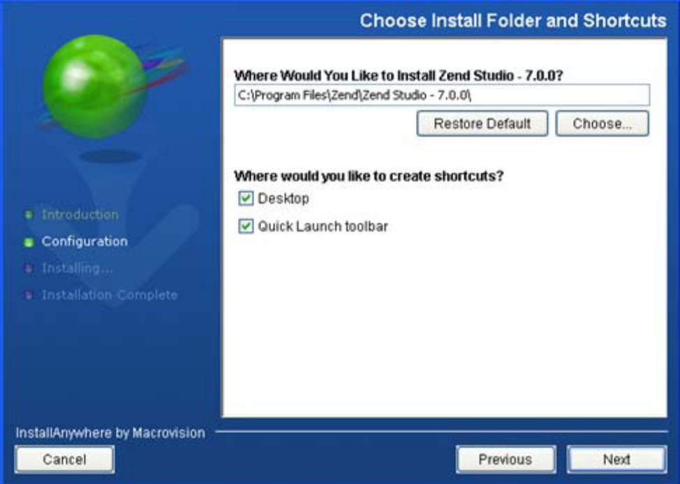
8. Select the location for your Zend Studio installation. To browse to the required location, click Choose.
9. Mark the checkboxes of the locations where you would like to create shortcuts.
10. Click Next. The Extension Association screen is displayed.
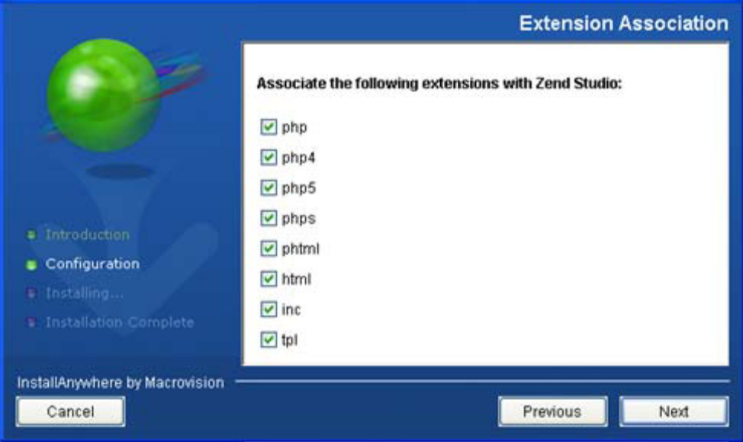
11. Select the checkboxes of the file extensions to associate with Zend Studio. Whenever a file with the corresponding extension is opened, it will be launched in a Zend Studio editor.
12. Click Next. The Pre-Install Summary screen is displayed.
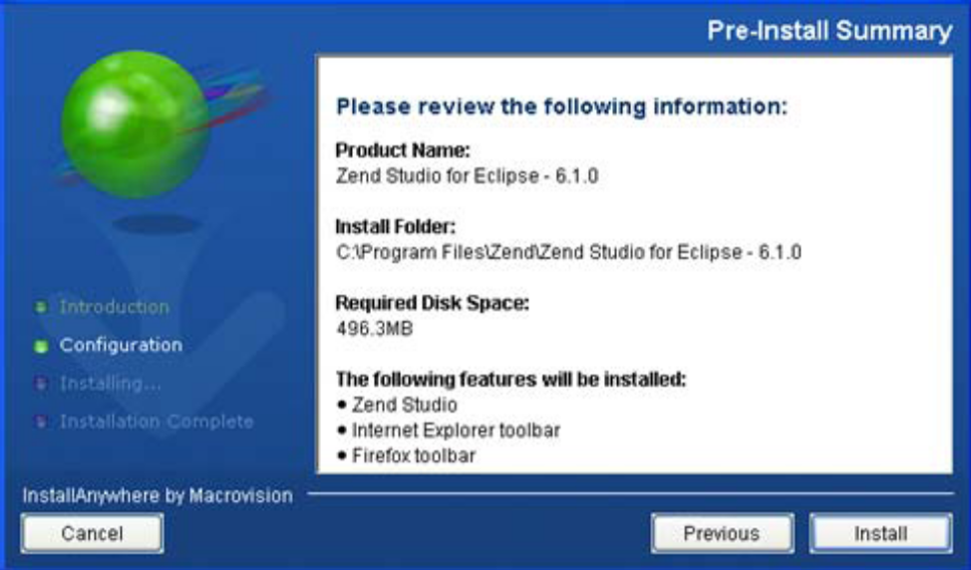
13. Verify that the information is correct and click Install. If you want to change the installation details, click Previous.
14. Once you click Install, the installation process will launch. A progress bar will be displayed on the bottom of the installation window to indicate the installation’s progress.
15. Once installation has completed, the Installation Complete screen is displayed.
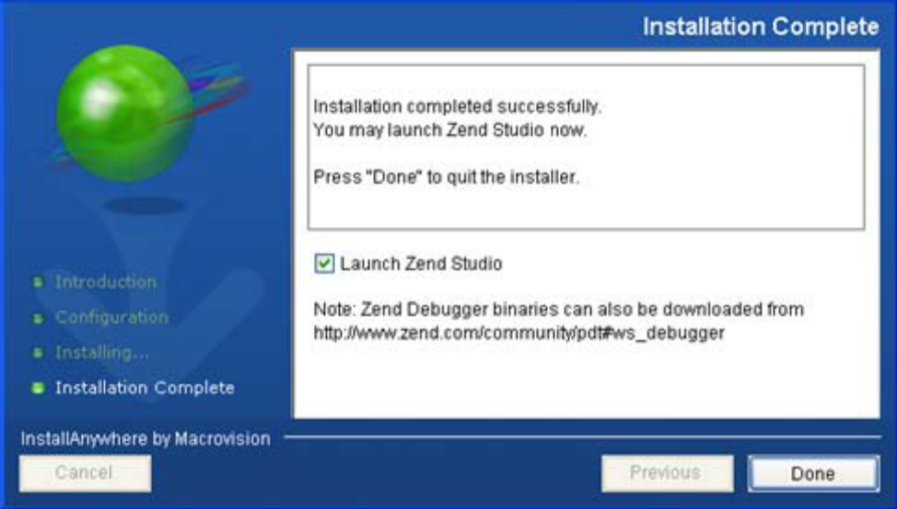
16. Mark the ‘Launch Zend Studio’ checkbox for Studio to be launched.
17. Click Done to exit the installation process.

0.2. INSTALL ZEND SERVER COMMUNITY

0.2.1. Download Zend Server Community Edition
Download @ http://www.zend.com/products/server/downloads-all

0.2.2. Install Zend Server Community Edition
- After completing the download, double-click on the .exe file to start the installation process.
- There are three installation types available: Typical, Full, and Custom. You choose Custom mode:
  - The Custom installation type gives you complete control over which packages you wish to install and the installation path that is used. The components are Zend Optimizer+, Zend Loader, Zend Debugger, Zend Cache, Java Server, Zend Framework, Oracle OCI Driver, phpMyAdmin, IBM DB2 RTCL and MySQL.
- Click the NEXT button to advance to the Confirmation dialog.
- If you choose the Custom installation type, click the NEXT button to advance to the “Destination Location” dialog.
- Select a Web server on which to install the PHP and the Installation Location. Click the NEXT button to advance to the Select Features dialog.
- Select the features to install by double-clicking the check-box next to each feature. A single click on a feature in the list displays a description for the feature. Click the NEXT button to advance to the “Administration Interface Password” screen and from there, to the Confirmation dialog.
  - You should disable features such as: Informix, Oracle OCI Driver, IBM DB2 RTCL, because we will use MySQL as the default database.
  - You should disable features such as: Java server, Java bridge, because we just develop website based on PHP, HTML, CSS,
  - You should choose to install Apache 2.2.x as a default web server.
- The Confirmation Dialog
Once you choose an installation type and choose your installation components, you advance to the confirmation dialog.
Your installation type and installation path are displayed for you to review.
- To install Zend Server CE (if you are satisfied with your settings), click the INSTALL button. To change your settings, click the BACK button.
- To exit the Zend Server CE Installation Wizard without installing Zend Server CE, click the CANCEL button.
- The Custom Installation
The custom installation installs select components and provides an option to choose the Web server on which to install PHP. After confirming the installation, if the port number is already in use, you are asked to specify a different port number. The selected Web server is configured to the port specified after completing the installation.
Installation on Windows is also quite simple. Start up the installer, and you should see a screen like this:
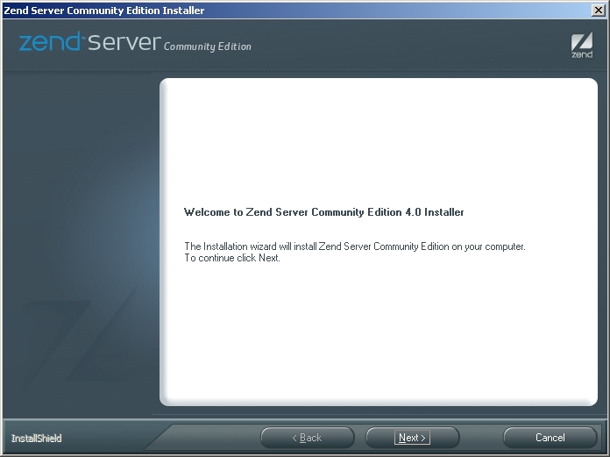
Work your way through the initial screens and choose a custom installation. You should then have the option of selecting various components, as in the following screenshot:
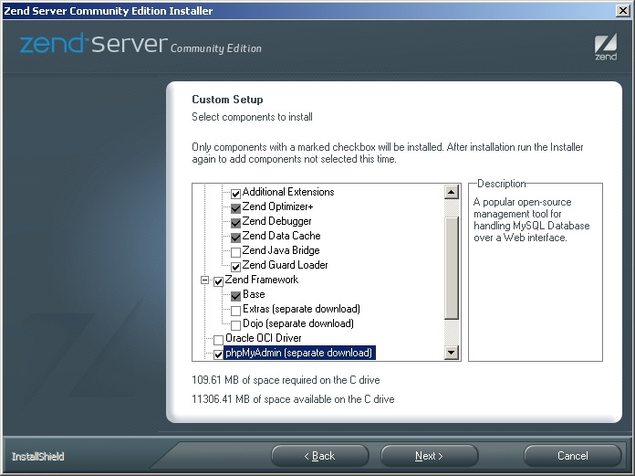
Notice that, in addition to a complete PHP installation, Zend Server CE includes the Zend Debugger for debugging, and the Zend Optimizer and Zend Data Cache for performance optimization. You should definitely install these components, as they come in handy when developing Web-based applications. Zend Server CE also includes the Zend Framework, which you should install if you expect to be doing any development with this framework.
A number of other add-ons are also available under Windows, including Dojo (don't install unless your project specifically needs it), MySQL (install if you don't already have it), phpMyAdmin (install to make MySQL management simpler), and various database drivers (only install the ones you expect to be using).
Once you've selected the components, also select the Web server type and port number - Apache 2.2.x on port #80 should do fine for most installations:
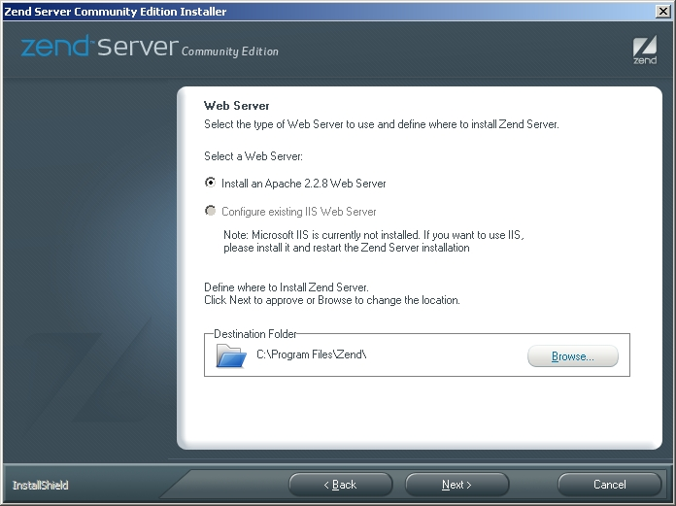
Review your installation settings, and confirm them to begin the installation process.
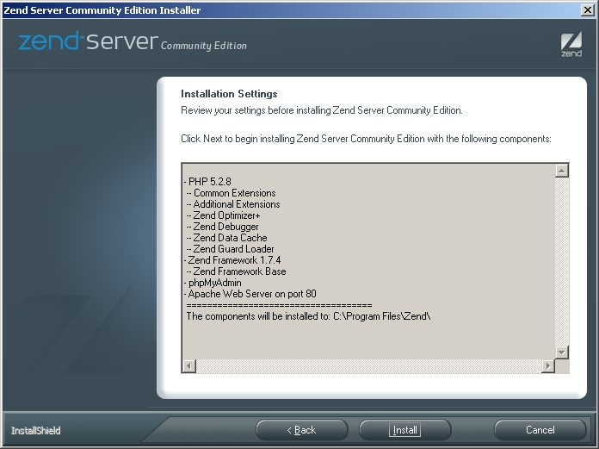
Zend Server CE will begin installing, downloading files as needed to complete the installation.
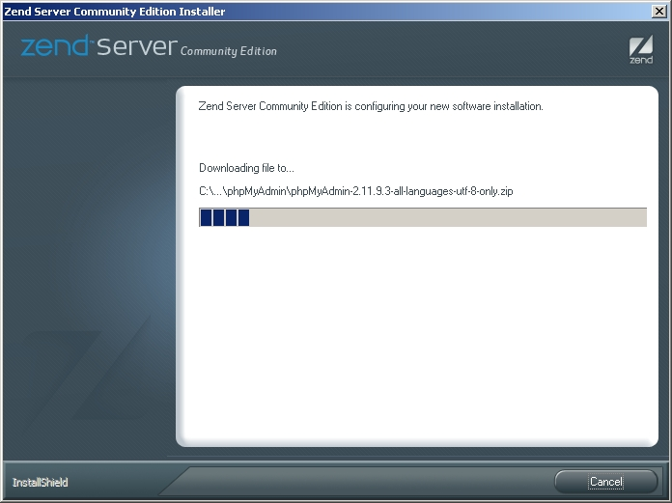
Once the installation process is complete, the installer's last task will be to automatically start the Apache Web server, and then launch the Zend Server CE administration console in a new browser window. Under Linux, you'll have to do this step manually, by accessing the administration URL provided at the end of the installation process.
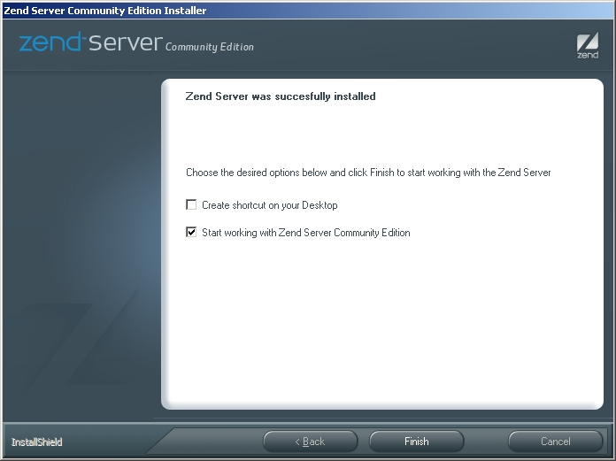
Since this is the server's first run, Zend Server CE will first ask you to set a password, which will be needed for all subsequent visits to the administration console. Once you've set a password, you'll be granted access to the main server administration console, which looks something like this:
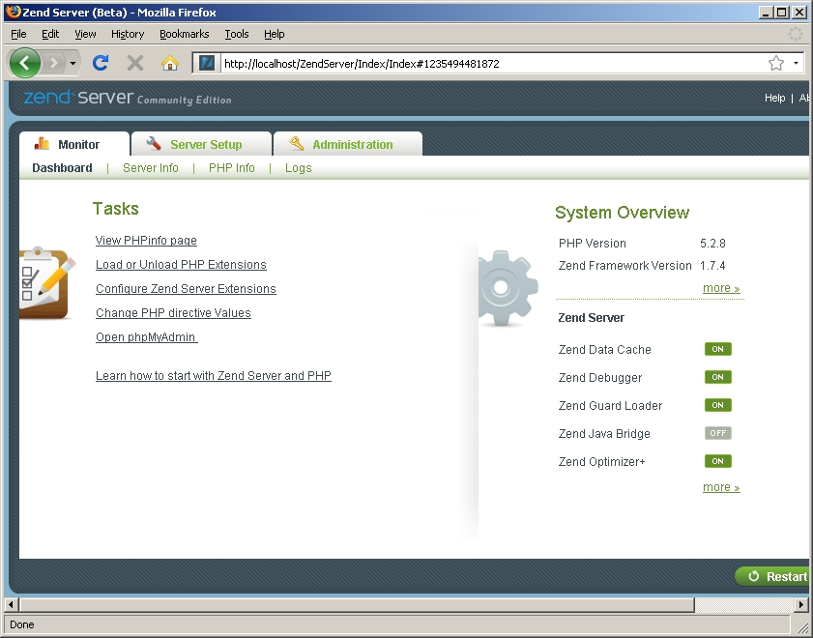

0.3. INTEGRATED ADMINISTRATION CONSOLE

0.3.1. Monitor
This section provides run-time information on the server process. A dashboard provides at-a-glance information on version information, as well as on the status of various Zend components such as the Zend Data Cache and Zend Optimizer. There are also separate pages for viewing PHP information, via the phpinfo() command, and the server's error and access logs.
Here are some screenshots illustrating what you might see in this section:
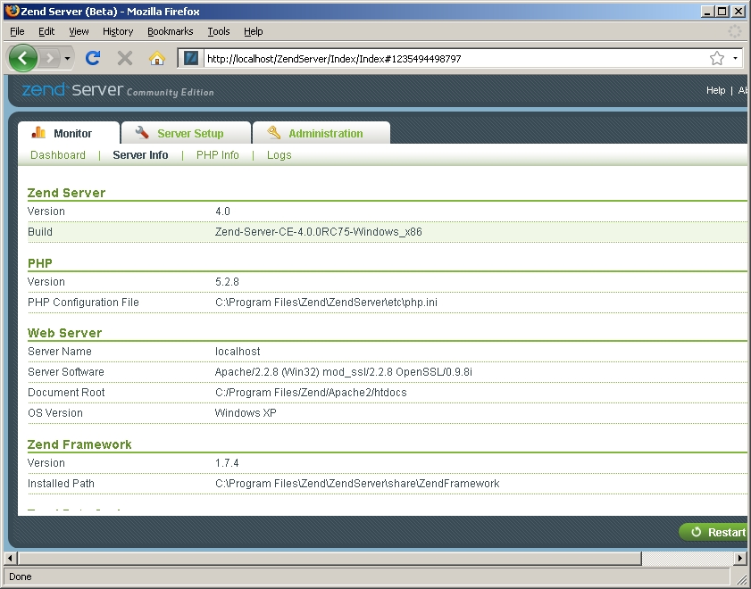
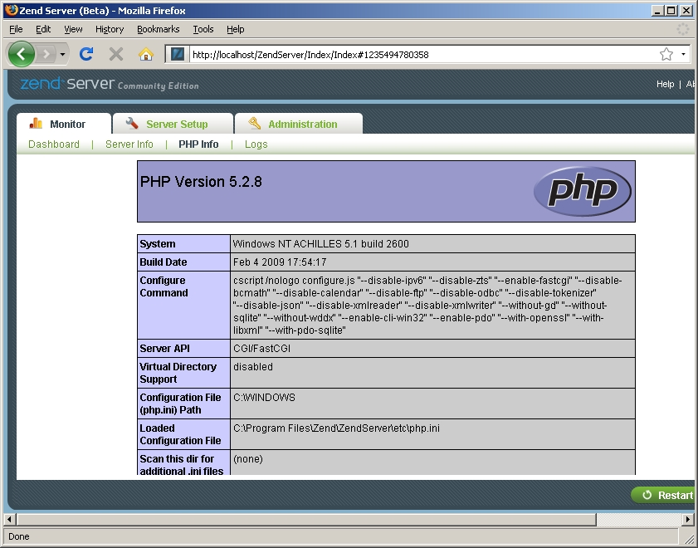

0.3.2. Server setup
The Monitor section provides information on the server's current state, and is great for when you need a quick visual check that everything's running smoothly. However, if you need to make changes, you need to instead head over to the Server Setup section, which allows you to modify the server's configuration. This section allows you to turn the various Zend tools on or off, enable or disable PHP extensions, change PHP configuration, and restart the server to have your PHP configuration changes take effect. All of these changes can be made via the browser-based interface, and every variable comes with an explanatory note, making reconfiguration a far simpler process than it normally is (especially for users new to PHP).
It's worth pointing out also that Zend Server CE also comes with built-in hooks for debugging PHP scripts using the Zend Studio debugger. Within the Server Setup section, you can allow or deny access to the debugging system for specific clients, using IP address masks.
Here are some screenshots illustrating what you might see in this section:
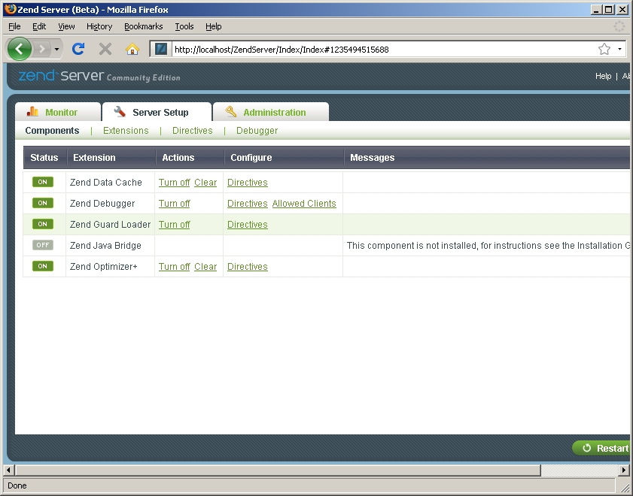
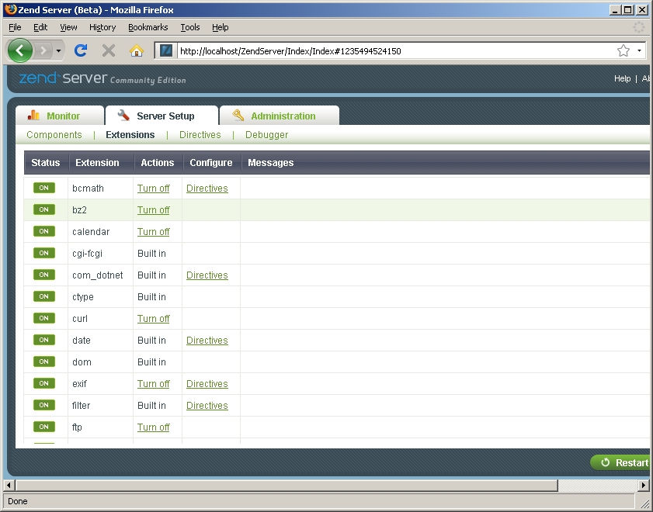
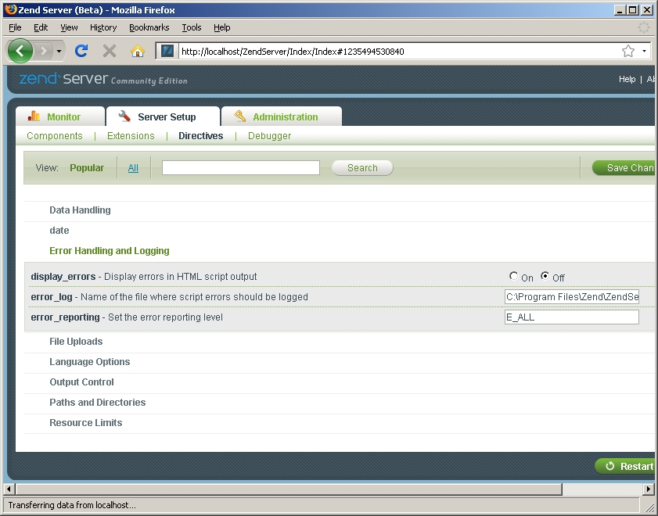

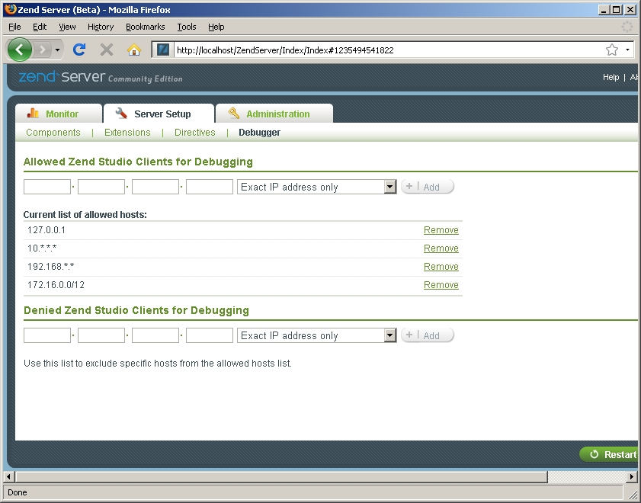

0.3.3. Administration:
The third section, Administration, merely allows you to change the password used to gain access to the administration console.
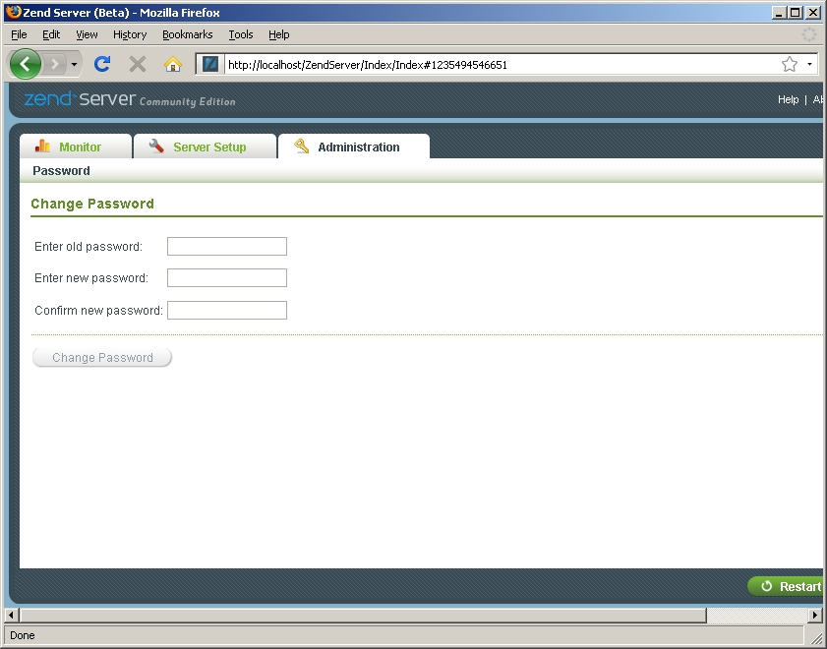

0.4. HELLO WORLD
At this point, Zend Server CE is fully set up. In order to test the installation and verify that your PHP code is being correctly parsed, pop open a text editor and create a simple PHP script containing the following code:
<?php
echo strtoupper('Welcome to PHP v' . phpversion());
?>
Save this script as 'welcome.php' in the Web server's document root directory. If you kept the installation defaults, this directory will be located at 'C:\Program Files\Zend\Apache2\htdocs' under Windows, while under Linux it will be located at '/usr/local/zend/apache2/htdocs' (you can also obtain the correct value from the Monitor -> Server Info -> Web Server section of the Zend Server CE administration console). Then, point your browser to 'http://localhost/welcome.php' (Windows) or 'http://localhost:10088/welcome.php' (Linux), and you should see something like this:
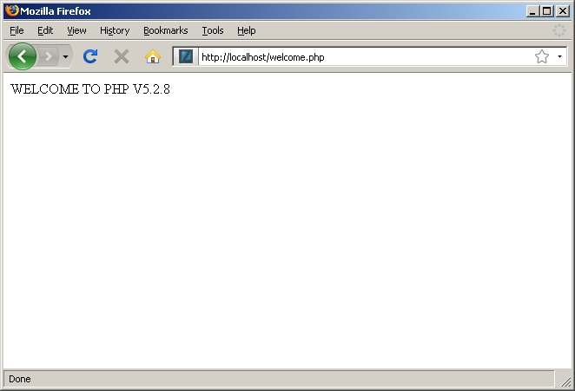

0.5. EXAMPLE PROJECT

0.5.1. Creating the Zend Framework Example Project
To create a Zend Framework Example Project:
Go to File | New | Example | Zend Framework Example Project.
The new Zend Framework Example Project wizard will open.
Enter a name for your example project.
An example project will be created and displayed in PHP Explorer view.
You can navigate through the application source files to learn more about the source behind the application.

0.5.2. Apache configuration
In order to run this example in Zend Studio, you need to include the ExampleProject directory to the path of web server.

Put these lines in the end of the httpd.conf in "C:\Program Files\Zend\Apache2\conf"
====
<Location /ExampleProject>
Order deny,allow
Allow from all
</Location>

Alias /ExampleProject "C:\Documents and Settings\$YourAccount\Zend\workspaces\DefaultWorkspace7\ExampleProject"
====

0.5.3. Run ExampleProject
Go to Run/Run (or Ctrl+F11) to run the project.
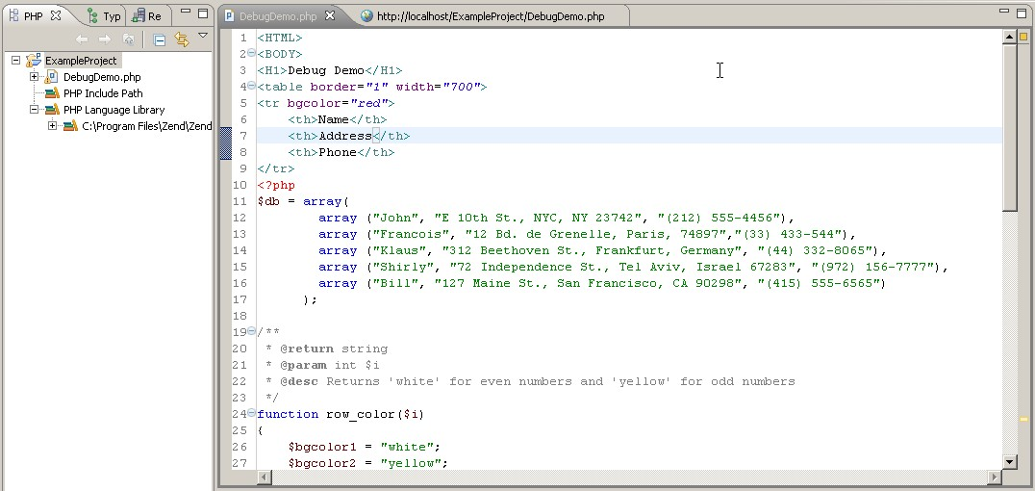

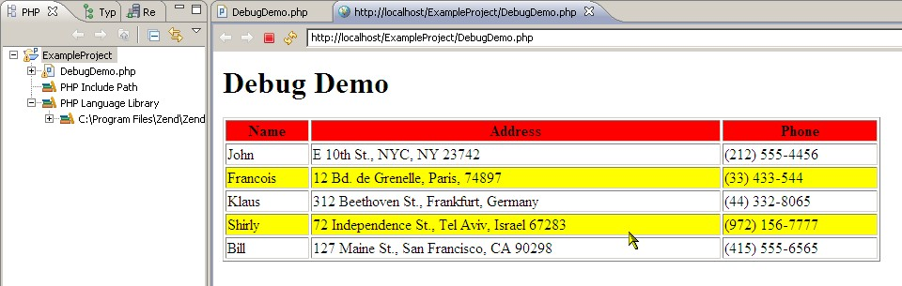
REFERENCES

[1] http://files.zend.com/help/Zend-Server-Community-Edition/installation_guide.htm
[2] www.zend.com
[3] http://devzone.zend.com/tutorials
[4] http://devzone.zend.com/article/4295

